Main Content in Voting Page

Background-Color: white;

Backgroud-image: A catpaw icon which is the same color as our theme color;

Button:

Font-size: 14px; 11px(when width of screen is less than 783px);

Color: white

Background-color: #5a4d69;

Background-color(Hover): #f6cbd9;

Align: center

Image Div:

Justify-content: center;

Height: 70vh, 40vh(when width of screen is less than 783px);

Width: 33vh, 24vh(when width of screen is less than 783px);

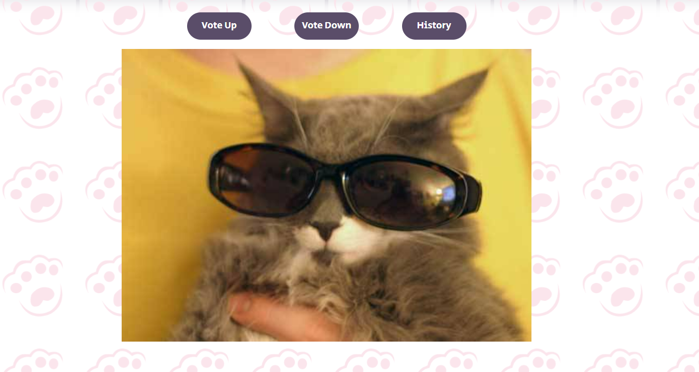

Display page’s button:

Width: 100px(120px when width of screen is less than 783px);

Font-size: 14px; 11px(when width of screen is less than 783px);

Color: white

Background-color: #5a4d69;

Background-color(Hover): #f6cbd9;

Align: center



Gallery Part:

Outer Div:

width: -webkit-fill-available;

height: -webkit-fill-available;

Inner Divs:

height: 200px;

width: 200px;

overflow: hidden;

margin: 10px 4.5vw 0 4.5vw;

position: relative;

flex-basis: 30%;

overflow: hidden;

display: inline-block;

Border:

border-color: #5a4d69 or #f6cbd9;

border-style: solid;

border-width: thick;

border-radius: 10px;

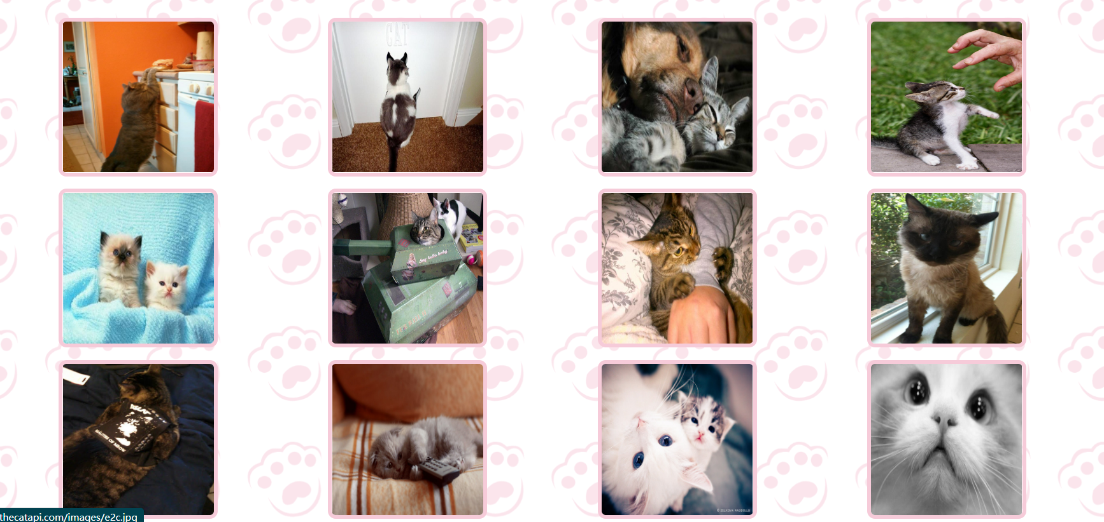

Breed Page:

Search Bar:

margin: auto;

margin-top: 10px;

width: 30%;

min-width: 450px;

height: 60px;

background-color: white;

border-radius: 50rem;

border: solid 2px #f6cbd9;

padding: 5px;

display: flex;

flex-direction: row;



Image outer div:

display: flex;

flex-direction: column;

align-items: center;

min-height: 532px;

Image Divs:

height: 50%;

object-fit: cover;

Images inside divs:

height: 200px;

width: 270px;

Breed names:

Font-size: 14pt;

Descriptions:

Font-size: 12pt;

Text-align: center.

